**Assignment No. 6**

* ***Aim:***

Collection of digital meter data using RS 485 / Ethernet / WiFi (datalogger/PC) and analyzing it using software.

* ***Apparatus:***

Ethernet / RS485 / Wifi (datalogger/PC) Digital Display Multi meters, Panel meters.

* ***Objective:***

1. To demonstrate different communication technologies and the process of collecting data from the digital / smart meters.

2. To demonstrate advanced instruments and different software tools.

* ***Outcome:***

Students will be able to:

1. Select appropriate communication technology to log data from the digital / smart meters.
2. Use relevant software tools to prepare the basic report from the data received from digital / smart meters.

* ***Theory:***

In the practical session, we explored real-time data collection from digital/smart meters, highlighting instantaneous values like voltage and current. Recognizing the inefficiency of manually recording readings at regular intervals, a solution was implemented to transfer data directly to a supervising person's device via connections like Ethernet/RS485, eliminating the need for physical checks and note-taking. Despite this improvement, accessing past readings remained a challenge due to digital meters displaying only current values. To overcome this, specialized software tools were introduced for data logging and report generation at specified intervals. Recent advancements include predictive features using historical data, aiding in anomaly detection, while the integration of Artificial Intelligence further streamlines tasks such as logging, security, and alerting.

* **RS-485** is the most common serial interface utilized today because it offers better functionality than RS-232. This serial interface boasts a greater data rate and range than RS-232. RS-485 also supports multipoint configurations. RS-485’s support for multipoint configurations allows you to link many receivers and transmitters to create a small network of devices.
* **Connection Diagram**:

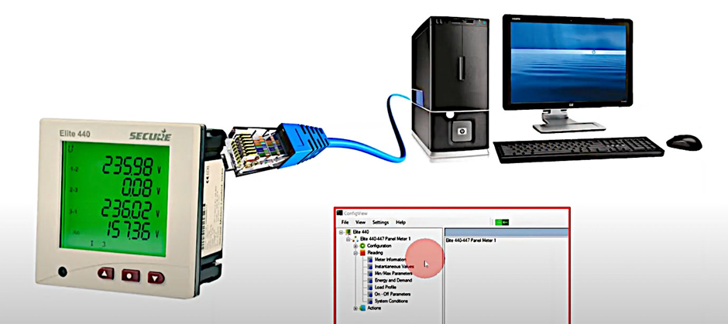

* + - **ConfigView** which is an free open source app is used for analyzing the data input from smartmeter SECURE Elite 440.
* ***Observations:***

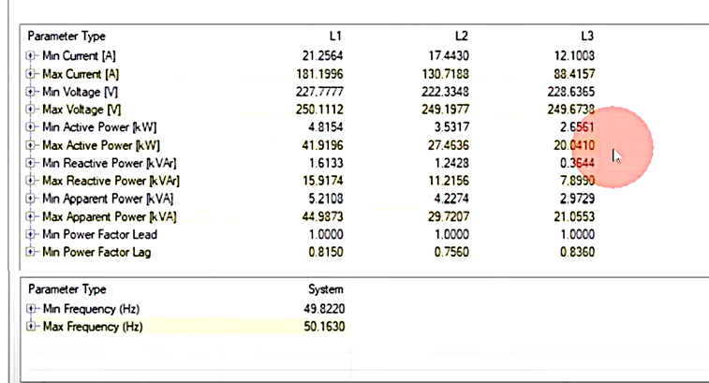 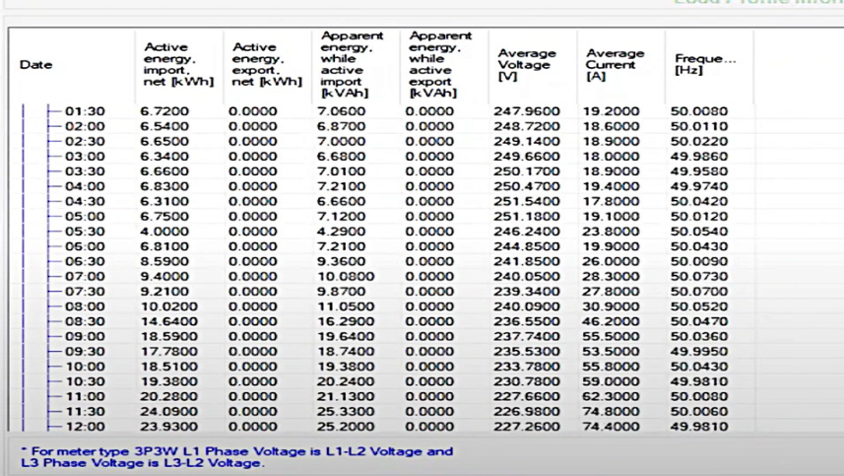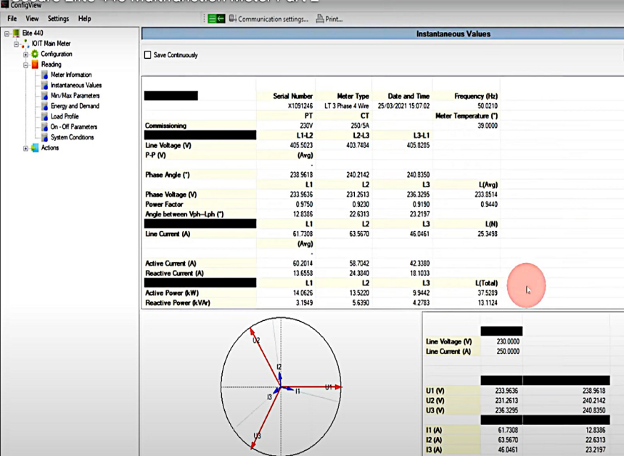

* ***Conclusion:***

Collected data from smart meter using Ethernet (datalogger/PC) and analyzed it using software.